**­­**

**­­­­­­­**

**LAB # 05**

|  |  |
| --- | --- |
| **SUBMITTED TO­** | **­­­Esha E Noor Durrani** |
| **SUBMITTED BY** | **Muhammad Ayaan Farrukh- CS Blue** |
| **REGISTRATION NO.** | **B24F0488CS035** |

**­**

# **LAB TASK # 01:**

**Write question here.**

Print numbers 1-100 using for loop.

**SOURCE CODE:**

|  |
| --- |
| #include<iostream>  using namespace std;  int main()  {      for(int i=1 ; i<=100 ; i++)      {          cout<< i << " ";      }  } |

**OUTPUT:**

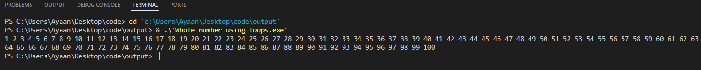

# **LAB TASK # 02:**

­­­­ **Write question here.**

Print odd numbers 1-100 using for loop.(1,3,5,7.....99).

**SOURCE CODE:**

|  |
| --- |
| #include<iostream>  using namespace std;  int main()  {      int num;      for(num=1; num <= 100; num++)      if(num % 2 != 0){        cout<< num << " ";        }  } |

**OUTPUT:**



# **LAB TASK # 03:**

**Write question here.**

Print even numbers 1-100 using for loop.(2,4,6,8....100)

**SOURCE CODE:**

|  |
| --- |
| #include<iostream>  using namespace std;  int main()  {   int num;   for(num = 1; num <= 100; num ++ )   if(num % 2 == 0){      cout<< num << " ";        }    } |

**OUTPUT:**



# **LAB TASK # 04:**

**Write question here.**

Print your formatted name 100 times using for loop.

**SOURCE CODE:**

|  |
| --- |
| #include<iostream>  using namespace std;  int main()  {    string name = "Muhammad Ayaan Farrukh";    for(int i = 1; i<=100 ; i++)    {      cout<< i << "." << name << " ";    }  } |

**OUTPUT:**

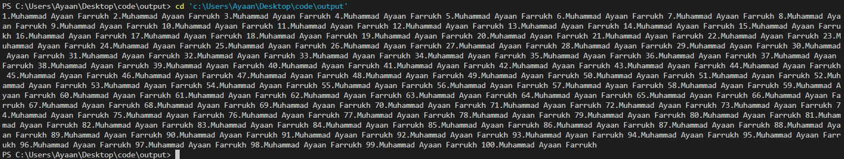

# **LAB TASK # 05:**

**Write question here.**

Print factorial of a number.

**SOURCE CODE:**

|  |
| --- |
| #include<iostream>  using namespace std;  int main()  {      long sum = 1;      long n;      cout<<"Enter the Number for Factorial: ";      cin>> n;      for (int i = n; i >= 1; --i)      {         sum *= i;      }      cout<< n << "! is " << sum ;  } |

**OUTPUT:**

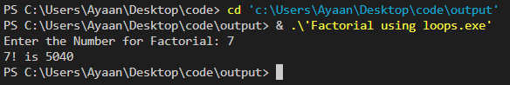

# **LAB TASK # 06:**

**Write question here.**

Print Fibonacci series.

**SOURCE CODE:**

|  |
| --- |
| #include<iostream>  using namespace std;  int main()  {     int n;     cout <<"Enter the number of terms: ";     cin>> n;     int first = 0, second = 1, next ;     cout<<"Fibonuccci Series: " << first << " "<< second << " ";     for(int i = 3; i <=n; i++ ){     next = first + second;     cout << next << " ";     first = second;     second = next;    }  } |

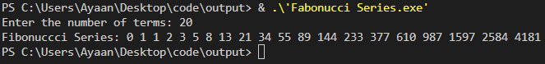**OUTPUT:**